Camilo Andrés Quintero Rodríguez

Grupo 6

Sección 2.6: **2,11**,**12**,**13**,**14**,**18**,**19**, **23**



$$\left(a≡\left(\left(¬a\right)∨b\right)\right)$$

|  |  |  |  |  |
| --- | --- | --- | --- | --- |
| $$a$$ | $$b$$ | $$\left(¬a\right)$$ | $$\left(\left(¬a\right)∨b\right)$$ | $$\left(a≡\left(\left(¬a\right)∨b\right)\right)$$ |
| F | F | T | T | F |
| F | T | T | T | F |
| T | F | F | F | F |
| T | T | F | T | T |

$$la naturaleza de a y b es a=T y b=T, lo que significa que ambos son caballeros$$

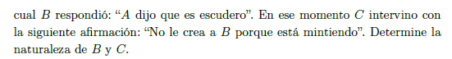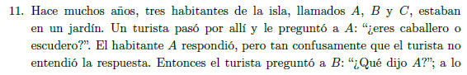

$$((b≡(a≡\left(¬a\right))⋀(c≡\left(¬b\right))$$

$$método de valuaciones$$

$v((b≡(a≡\left(¬a\right))⋀(c≡\left(¬b\right))=T Suposición$

$v((b≡(a≡\left(¬a\right))=T Met. 2.23 caso ⋀$

$v\left(c≡\left(¬b\right)\right)=T Met. 2.23 caso ⋀$

$v\left(b\right)=v(a≡\left(¬a\right) Met. 2.23 caso ≡paso 2$

$v\left(c\right)=v\left(¬b\right) Met. 2.23 caso ≡paso 3$

3. a. $v\left(b\right)=F b. v\left(b\right)=T Nota 2.20$
4. a. $v(a≡\left(¬a\right))=F b.v(a≡\left(¬a\right))=T Transitividad de la igualdad paso 6, 4$
5. *a. $v\left(¬b\right)=T b.v\left(¬b\right)=F Met. 2.23 caso ¬ paso 6$*
6. a. $v\left(c\right)=T b. v\left(c\right)=F Transitividad de la igualdad paso 5, 8$

$b. v\left(a\right)=v\left(¬a\right) Met. 2.23 caso ≡paso 7.b$

$b. contradicción en a por Nota 2.20$

$$v\left(c\right)=T , C es caballero v\left(b\right)=F, B es escudero$$

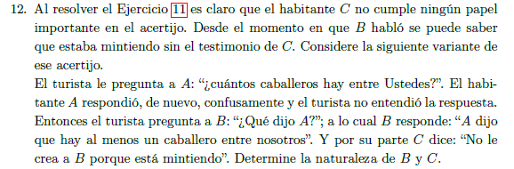

$$((b ≡ (a ≡ (a ∨ (b ∨ c)))) ∧ (c ≡ (¬b)))$$

$$Metodo de tabla$$

|  |  |  |  |  |  |  |  |  |
| --- | --- | --- | --- | --- | --- | --- | --- | --- |
| a | b | c | $$(b ∨ c)$$ | $$(a ∨ (b ∨ c))$$ | $$(a ≡ (a ∨ (b ∨ c)))$$ | $(b ≡ (a ≡ (a ∨ (b ∨ c))))$ | $$(¬b)$$ | $$(c ≡ (¬b))$$ |
| F | F | F | F | F | T | F | T | F |
| F | F | T | T | T | F | T | T | T |
| F | T | F | T | T | F | F | F | T |
| F | T | T | T | T | F | F | F | F |
| T | F | F | T | T | T | F | T | F |
| T | F | T | T | T | T | F | T | T |
| T | T | F | T | T | T | T | F | T |
| T | T | T | T | T | T | T | F | F |

|  |  |  |
| --- | --- | --- |
|  |  |  |
| F | F | F |
| T | T | T |
| F | T | F |
| F | F | F |
| F | F | F |
| F | T | F |
| T | T | T |
| T | F | F |

$$No es posible determinar la naturalezade B y D, pues las valuaciones son diferentes en cada caso$$

$$en el que la expresion es verdadera.$$

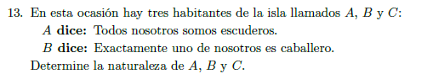

$$\left(a≡\left(\left(¬a\right)∧\left(¬b\right)∧\left(¬c\right)\right)\right)$$

$$\left(b≡\left(\left(a∧\left(¬c\right)∧\left(¬b\right)\right)∨\left(\left(¬a\right)∧c∧\left(¬b\right)\right)∨\left(\left(¬a\right)∧\left(¬b\right)∧b\right)\right)\right)$$

$$\left(\left(a≡\left(\left(¬a\right)∧\left(¬b\right)∧\left(¬c\right)\right)\right)∧\left(b≡\left(\left(a∧\left(¬c\right)∧\left(¬b\right)\right)∨\left(\left(¬a\right)∧c∧\left(¬b\right)\right)∨\left(\left(¬a\right)∧\left(¬b\right)∧b\right)\right)\right)\right)$$

|  |  |  |  |  |  |  |  |
| --- | --- | --- | --- | --- | --- | --- | --- |
| a | b | c | $$\left(¬a\right)$$ | $$\left(¬b\right)$$ | $$\left(¬c\right)$$ | $$\left(\left(¬a\right)∧\left(¬c\right)∧\left(¬b\right)\right)$$ | $$\left(a≡\left(\left(¬a\right)∧\left(¬c\right)∧\left(¬b\right)\right)\right)$$ |
| F | F | F | T | T | T | T | F |
| F | F | T | T | T | F | F | T |
| F | T | F | T | F | T | F | T |
| F | T | T | T | F | F | F | T |
| T | F | F | F | T | T | F | F |
| T | F | T | F | T | F | F | F |
| T | T | F | F | F | T | F | F |
| T | T | T | F | F | F | F | F |

|  |  |  |  |  |  |  |  |  |  |
| --- | --- | --- | --- | --- | --- | --- | --- | --- | --- |
| a | b | c | $$\left(¬a\right)$$ | $$\left(¬b\right)$$ | $$\left(¬c\right)$$ | $$\left(a∧\left(¬c\right)∧\left(¬b\right)\right)$$ | $$\left(\left(¬a\right)∧c∧\left(¬b\right)\right)$$ | $$\left(\left(¬a\right)∧\left(¬c\right)∧b\right)$$ | $$\left(\left(a∧\left(¬c\right)∧\left(¬b\right)\right)∨\left(\left(¬a\right)∧c∧\left(¬b\right)\right)∨\left(\left(¬a\right)∧\left(¬b\right)∧b\right)\right)$$ |
| F | F | F | T | T | T | F | F | F | F |
| F | F | T | T | T | F | F | T | F | T |
| F | T | F | T | F | T | F | F | T | T |
| F | T | T | T | F | F | F | F | F | F |
| T | F | F | F | T | T | T | F | F | T |
| T | F | T | F | T | F | F | F | F | F |
| T | T | F | F | F | T | F | F | F | F |
| T | T | T | F | F | F | F | F | F | F |

|  |  |
| --- | --- |
|  |  |
| F | T |
| T | F |
| T | T |
| T | F |
| F | F |
| F | T |
| F | F |
| F | F |

|  |
| --- |
|  |
| F |
| F |
| T |
| F |
| F |
| F |
| F |
| F |

$$Despues de desarrollar la tabla, podemos concluir que$$

$$B es caballero, C es escudero$$

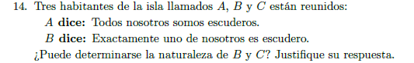

$$\left(a≡\left(\left(¬a\right)∧\left(¬c\right)∧\left(¬b\right)\right)\right)$$

$$(b≡(\left(\left(¬a\right)∧c∧b\right)∨\left(a∧\left(¬c\right)∧b\right)∨\left(a∧c∧\left(¬b\right)\right))$$

$\left(\left(a≡\left(\left(¬a\right)∧\left(¬c\right)∧\left(¬b\right)\right)\right)∧\left(b≡\left(\left(\left(¬a\right)∧c∧b\right)∨\left(a∧\left(¬c\right)∧b\right)∨\left(a∧c∧\left(¬b\right)\right)\right)\right)\right)$

|  |  |  |  |  |  |  |  |
| --- | --- | --- | --- | --- | --- | --- | --- |
| a | b | c | $$\left(¬a\right)$$ | $$\left(¬b\right)$$ | $$\left(¬c\right)$$ | $$\left(\left(¬a\right)∧\left(¬c\right)∧\left(¬b\right)\right)$$ | $$\left(a≡\left(\left(¬a\right)∧\left(¬c\right)∧\left(¬b\right)\right)\right)$$ |
| F | F | F | T | T | T | T | F |
| F | F | T | T | T | F | F | T |
| F | T | F | T | F | T | F | T |
| F | T | T | T | F | F | F | T |
| T | F | F | F | T | T | F | F |
| T | F | T | F | T | F | F | F |
| T | T | F | F | F | T | F | F |
| T | T | T | F | F | F | F | F |

|  |  |  |  |  |  |  |  |  |  |
| --- | --- | --- | --- | --- | --- | --- | --- | --- | --- |
| a | b | c | $$\left(¬a\right)$$ | $$\left(¬b\right)$$ | $$\left(¬c\right)$$ | $$\left(\left(¬a\right)∧c∧b\right)$$ | $$\left(a∧\left(¬c\right)∧b\right)$$ | $$\left(a∧c∧\left(¬b\right)\right)$$ | $$\left(\left(\left(¬a\right)∧c∧b\right)∨\left(a∧\left(¬c\right)∧b\right)∨\left(a∧c∧\left(¬b\right)\right)\right)$$ |
| F | F | F | T | T | T | F | F | F | F |
| F | F | T | T | T | F | F | F | F | F |
| F | T | F | T | F | T | F | F | F | F |
| F | T | T | T | F | F | T | F | F | T |
| T | F | F | F | T | T | F | F | F | F |
| T | F | T | F | T | F | F | F | F | F |
| T | T | F | F | F | T | F | F | F | F |
| T | T | T | F | F | F | F | F | F | F |

|  |  |
| --- | --- |
|  |  |
| F | T |
| T | T |
| T | F |
| T | F |
| F | T |
| F | T |
| F | F |
| F | F |

|  |
| --- |
|  |
| F |
| T |
| F |
| F |
| F |
| F |
| F |
| F |







$$Despues de desarrollar la tabla, podemos concluir que A y B son escuderos mienstras C es caballero$$

$$B es escudero, C es caballero$$

$$A es el unico habitante de una isla, A dice que escaballero y escudero a la vez$$

$(a≡\left(a∧\left(¬a\right)\right) Proposición propuestas$

$v(a≡\left(a∧\left(¬a\right)\right)=T Proposición propuestas$

$v\left(a\right)=v\left(a≡\left(¬a\right)\right) Met. 2.23 caso ≡paso 2$

$a. v\left(a\right)=F b. v\left(a\right)=T Nota. 2.20$

$a. v\left(¬a\right)=T b. v\left(¬a\right)=F Met. 2.23 caso ¬ paso 4$

$a. v\left(a≡\left(¬a\right)\right)=F b. v\left(a≡\left(¬a\right)\right)=T Transitividad de la igualdad paso 3 y 4$

$a. v\left(a\right) ≠v\left(¬a\right) b. v\left(a\right)=v\left(¬a\right) Met. 2.23 caso ≡paso 6$

$b. contradiccion Nota 2.20$

$a. Concluimos que A es escudero$

$\left(a≡\left(a→b\right)\right) Proposicion propuesta$

$v\left(a≡\left(a→b\right)\right)=T Suposición$

$v\left(a\right)=v\left(a→b\right) Met. 2.23 caso ≡paso 2$

$a. v\left(a\right)=T b. v\left(a\right)=F Nota 2.20$

$a. v\left(a→b\right)=T b. v\left(a→b\right)=F Transitividad de la igualdad paso 3 y 4$

1. $a. v\left(a\right)=v\left(b\right)=T$ b. $Contradiccion Met. 2.23 caso→paso 4 y 5$

$A y B son caballeros$

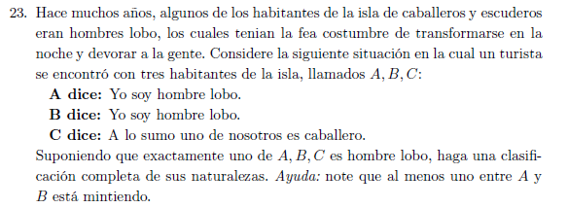

$\left(c≡\left(\left(a∧\left(¬b\right)∧\left(¬c\right)\right)∨\left(\left(¬a\right)∧b∧\left(¬c\right)\right)∨\left(\left(¬a\right)∧\left(¬b\right)∧c\right)∨\left(\left(¬a\right)∧\left(¬b\right)∧\left(¬c\right)\right)\right)\right)$

|  |  |  |  |  |  |  |  |  |  |
| --- | --- | --- | --- | --- | --- | --- | --- | --- | --- |
| a | b | c | $$\left(¬a\right)$$ | $$\left(¬b\right)$$ | $$\left(¬c\right)$$ | $$\left(\left(¬a\right)∧\left(¬c\right)∧\left(¬b\right)\right)$$ | $$\left(a∧\left(¬c\right)∧\left(¬b\right)\right)$$ | $$\left(\left(¬a\right)∧b∧\left(¬c\right)\right)$$ | $$\left(\left(¬a\right)∧\left(¬b\right)∧c\right)$$ |
| F | F | F | T | T | T | T | F | F | F |
| F | F | T | T | T | F | F | F | F | T |
| F | T | F | T | F | T | F | F | T | F |
| F | T | T | T | F | F | F | F | F | F |
| T | F | F | F | T | T | F | T | F | F |
| T | F | T | F | T | F | F | F | F | F |
| T | T | F | F | F | T | F | F | F | F |
| T | T | T | F | F | F | F | F | F | F |

|  |
| --- |
|  |
| F |
| T |
| T |
| F |
| T |
| F |
| F |
| F |

|  |
| --- |
|  |
| T |
| T |
| F |
| F |
| F |
| F |
| T |
| F |

$$A y B mienten y son escueros,C es el hombre lobo$$